**Software Requirements Specification (SRS) Document**

**For**

**Online Pet Care System**

**Submission Date: 13.01.2024**

**Group Number: 20**

**Group Members:**

|  |  |  |
| --- | --- | --- |
|  | **Student Reg. No** | **Student Name** |
| 01. | 220100041 | A.Tharushka Heshan |
| 02. | 220100129 | M.A.S.Supun Himansa |
| 03. | 220100137 | Nilupa Nirmal |
| 04. | 220100056 | Sachindu Madhushan Perera |
| 05. | 220100027 | Bimsara Jayawardhana |
| 06. | 220100059 | W.S.D.Ayeshani Kumarasiri |

**01 - INTRODUCTION**

**1.1 Scope**

**1.2 Purpose**

**1.3 Overall Description**

**1.3.1 Product Perspective**

**1.3.2 Product Features**

**1.3.3 User Classes and Characteristics**

**02 - FUNCTIONAL REQUIREMENTS**

**2.1 User Registration and Login**

**2.2 Dog Profile Management**

**2.3 Appointment Scheduling**

**2.4 Vaccination Tracking**

**2.5 Data Management by Administrators**

**2.6 User Stories**

**2.7 Use Case Diagram**

**2.8 Activity diagram**

**2.9 Use Case Scenario**

**2.10 Class diagram**

**03 - NON FUNCTIONAL REQUIREMENTS**

**3.1 Usability Requirements**

**3.2 Reliability Requirements**

**3.3 Performance Requirements**

**3.4 Security**

**3.5 Maintainability**

**04- CONSTRAINTS**

**4.1 Environmental Constraints**

**4.2 Regulatory Constraints**

**4.3 Technical Constraints**

**05 - VERIFICATION CRITERIA**

**5.1 User Acceptance Testing (UAT**

**5.2 Functional Testing**

**5.3 Performance Testing**

**06 - PROTOTYPING MODEL**

**07 – TEST CASES**

**08 – RESOURCES**

**O1.Introduction -->**

**1.1 Purpose :**

The purpose of this document is to define the requirements for the development of a Pet Care System that enables users to schedule veterinary appointments, track their dogs' vaccination details, receive notifications for missed or pending vaccinations, and allows veterinarians and administrators to manage and update data.

**1.2 Scope :**

This system will serve pet owners who want to manage multiple dogs, schedule veterinary appointments, and keep track of their dogs' vaccination history. Veterinarians and administrators will have the capability to update and manage records.

**1.3 Overall Description :**

**1.3.1 Product Perspective**

The Pet Care System will be a standalone system that interfaces with users (pet owners), veterinarians, and administrators. It does not integrate with external systems.

**1.3.2 Product Features**

* User registration and login.

* Dog profile management for users with the ability to manage multiple dogs.

* Appointment scheduling for veterinary visits.

* Vaccination tracking with notifications for missed or pending vaccinations.

* Veterinarians can update vaccination details.

* Administrators can edit all data.

**1.3.3 User Classes and Characteristics**

* Pet Owners: Users who own one or more dogs and want to schedule veterinary appointments and track vaccination details.

* Veterinarians: Users responsible for providing veterinary services and updating vaccination records.

* Administrators: Users with elevated privileges to edit all data within the system.

**02. Functional Requirements-->**

**2.1 User Registration and Login :**

*Pet owners, veterinarians, and administrators must register for an account.

* Secure login functionality.

**2.2 Dog Profile Management :**

* Pet owners can add, edit, or remove dog profiles.

* Each dog profile includes basic information and vaccination history.

**2.3 Appointment & Contact Scheduling :**

* Pet owners can schedule veterinary appointments.

* Veterinarians can view and manage their appointment schedules.

* Pet owners can find the nearest doctors.

* Pet owners can pay on online system to channel a doctors.

* Pet owners can send a massage about his problem using contact us.

* Veterinarians and Administrator can see and reply the pet owners massage

**2.4 Vaccination Tracking :**

* Pet owners receive notifications for upcoming, missed, or pending vaccinations.

* Pet owner can saw the pet’s vaccination reports.

* Veterinarians can update vaccination details for each dog.

**2.5 Data Management by Administrators :**

* Administrators have the ability to edit all data within the system.

* This includes user profiles, dog profiles, appointments, store and vaccination records

* Administrators can add or remove selling item.

**2.6 User Stories :**

*As a user, I want to Register to site.

*As a user, I want to Login to site.

* As a user, I want to create a profile for each of my pets.

* As a user, I want to see the my registered dogs and there details.

* As a user, I want to see my dogs vaccinations details.

* As a user, I want to contact the available persons who are responsible for the system and its problems.

* As a user, I want to see the the available services regarding to my dogs health.

* As a user, I want to see available doctors near my location.

* As a user, I want to see available doctors and the time available for them.

* As a user, I want to see the doctor and how many channels have be reserved at that time.

* As a user, I want to channel a doctor through the system.

* As a user, I want to see a detailed receipt about the channel.

* As a user, I want to check out the channelling process.

*As a user, I want to see the available categories of products.

* As a user, I want to see available products that dogs need like accessories.

*As a user, I want to add my desired products to cart.

*As a user, I want to buy things in my cart at ones. multiple products at ones.

*As a user, I want to remove items from the cart.

*As a veterinarian ,I want to Register to site.

*As a veterinarian ,I want to Login to site.

*As a veterinarian ,I want to see the clients pets and there information on the system.

*As a veterinarian ,I want to search dogs by there ID.

*As a veterinarian ,I want to see the details of history of vaccinations of dogs.

*As a veterinarian ,I want to update the vaccinations when vaccinate the dog.

*As a veterinarian ,I want to receive the user massages and reply to there problems.

*As a system Administrator, I want to Login site.

*As a system Administrator, I want to update and manage the doctors available to channel in the system.

*As a system Administrator, I want to update the available vaccinations for the dogs.

*As a system Administrator, I want to add and remove available items in the store .

*As a system Administrator, I want to receive the user massages and reply to there problems.

**2.7 Use Case Diagram:**

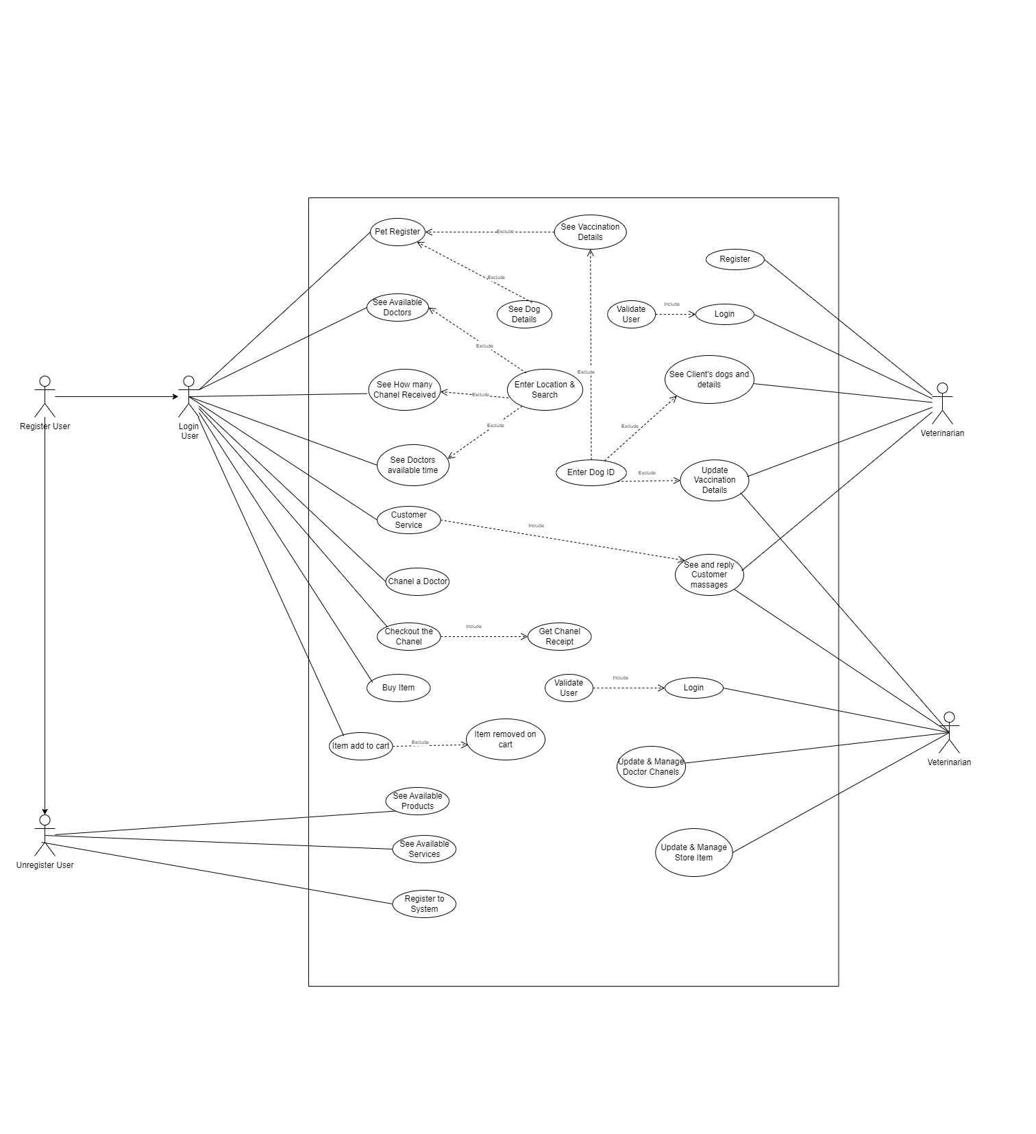

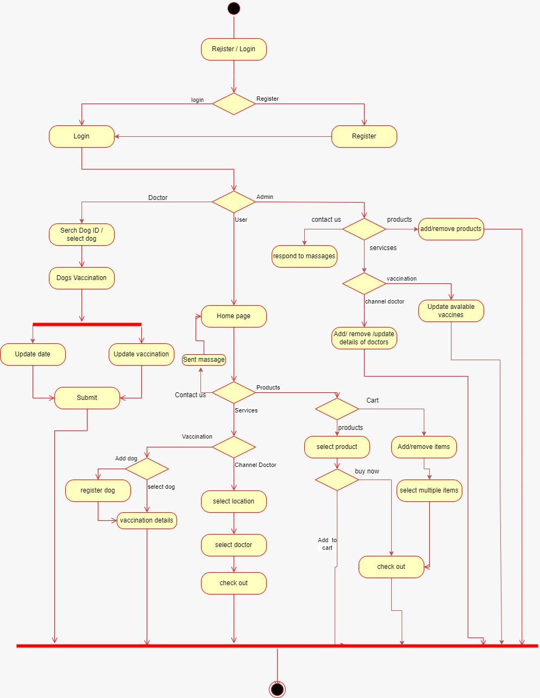

**2.8 Activity Diagram:**

**2.9 Use Case Scenario:**

*Create a profile for owners dog

* Actor :Pet owner/regular user
* Description : Pet owner want to create a profile for his dog.
* Pre conditions:User has to registered to the system.
* Flow of events: 1) user log into the system.
  + User navigate to the services page.
  + Select vaccination in the page.
  + Then click add dog button.
  + Then navigate to register dog page from there.
  + Fill the details Name, Age and details and submit.
* Post conditions: Details of dog saved under owners profile in the system.

* Channel a doctor through the system.

* Actor: Pet owner/regular user
* Description : Pet owner want to channel a doctor for dogs medical conditions.
* Pre conditions:User has to registered to the system.
* Flow of events: 1) user log into the system.
  + User navigate to the services page.
  + Select channel doctor in the page.
  + Then select his location.
  + Then web page shows the nearest doctors locations.
  + Then select a doctor and press channel button.
  + Then user navigate to check out page.
  + Then check out from there.
* Post conditions: Channel has stored in the system.
  + Number of channellings under the doctor in channelling page has updated.
  + Check out receipt has printed to the user with channelling details.

* Update the vaccination of a dog in the system.

* Actor :Doctor
* Description : Doctor wants to update the vaccination process of the dog after a vaccine.
* Pre conditions:Doctor has to registered to the system, Vaccinated dog has to have a profile in the system.
* Flow of events: 1) Doctor log in to the system.
  + Doctor navigate to the Vaccination page.
  + Search the dog by its ID.
  + Then select his location.
  + Then display the dog details and its vaccination details.
  + Doctor update the date and press vaccinate button in the related vaccine.
  + Then submit.
* Post conditions: Date of the vaccination and the status has stored in the system,
  + Date and status has updated in the dogs vaccination page.

* Add a doctor to the doctor channelling page.

* Actor: System administrator.
* Description : admin wants to add a new doctor to channelling system.
* Pre conditions:Admin has to registered to the system with privileges.
* Flow of events: 1) Doctor log in to the system.
  + admin navigate to the services page.
  + Then select channel doctor in the page.
  + Then click add doctor button.
  + Then fill the name description location and other details and submit**.**
* Post conditions: New doctor added to the system.
  + Channel doctor page update with new doctor when select the related location.

* Add new product to the Store.

* Actor: System administrator.
* Description : admin wants to add a new product to the store.
* Pre conditions:Admin has to registered to the system with privileges.
* Flow of events: 1) admin log into the system.
  + admin navigate to the store page.
  + Then select add product.
  + Then add the name ,price, description and other details.
  + Then submit.
* Post conditions: New product added to the database,
  + New item has shown in the store.

**2.10 Class Diagram:**

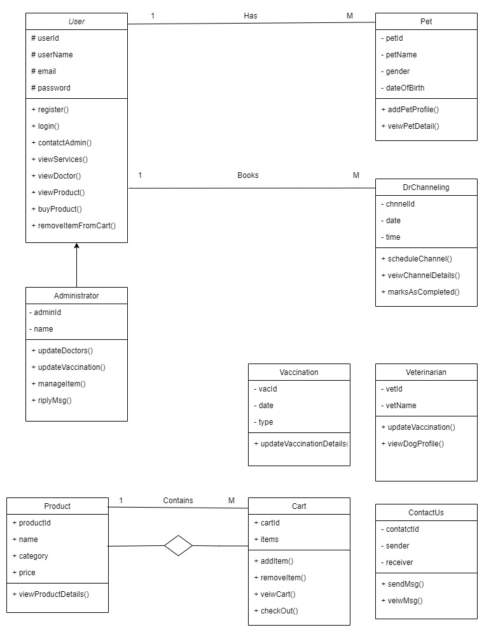

**03. Non-functional Requirements-->**

**3.1 Usability Requirements :**

The system present package details in a manner that is easy to read and comprehend for users.

Veterinarian channelling price, selling item details, and any other relevant information displayed using legible font sizes and styles to ensure readability.

The user can view his dog's details and enter as many dogs as he can.

**3.2 Reliability Requirements :**

* The system should be available 24/7 with minimal downtime.

* The system should be reliable, ensuring that users can access and update information consistently.

* The system has implemented strong security measures to protect customer confidentiality and integrity. Payment information is also confidential.

* User passwords securely stored in the system's database using encryption

**3.3 Performance Requirements :**

* The system should handle concurrent user interactions efficiently.

* The system should handle a concurrent user load without significant degradation in performance.

* The system should be able to handle minimum 500 concurrent users without significant declaration in performance

* The process of updating sold items and the payment process should be faster

**3.4 Security :**

**\*** The Pet Care System prioritizes security by enforcing robust user authentication, role-based access control, data encryption, and regular security audits to prevent unauthorized access and protect sensitive information**.**

**3.5 Maintainability :**

**\***To ensure long-term maintainability, the system adheres to coding standards, includes comprehensive documentation, implements modular design principles for easy updates, and employs continuous monitoring, automated testing, and systematic software upgrades.

**04. CONSTRAINTS-->**

**4.1 Environmental Constraints:**

The Pet Care System operates within the constraints of the user's device specifications, network connectivity, and compatibility with standard web browsers and mobile devices. It is dependent on the prevailing environmental conditions, such as internet stability and device capabilities

**4.2 Regulatory Constraints:**

The Pet Care System must adhere to local and international regulations governing pet care, veterinary services, and online platforms. Compliance with legal standards, privacy laws, and industry regulations is essential for system development and operation.

**4.3 Technical Constraints:**

The Pet Care System is constrained by the technical requirements of its underlying technologies, including compatibility with specific web browsers, mobile devices, and any dependencies on external frameworks or tools. The system's development and functionality are limited by the technical specifications and capabilities of the chosen technology stack.

**05. Verification Criteria-->**

**5.1 User Acceptance Testing (UAT):**

*End-users will validate the system by ensuring that they can successfully register, log in, manage pet profiles, schedule appointments, and perform other essential tasks.

*Acceptance will be based on users' satisfaction with the system's usability and fulfilment of their requirements.

**5.2 Functional Testing:**

*Each functional requirement outlined in the SRS will have corresponding test cases.

*Verification will involve executing these test cases to confirm that the system functions as specified, including user registration, appointment scheduling, vaccination tracking, and data management.

**5.3 Performance Testing:**

*Criteria for assessing system performance under different conditions will be defined.

*The system's responsiveness, speed, and ability to handle concurrent user interactions will be evaluated to ensure optimal performance.

**06. Prototyping Model-->**

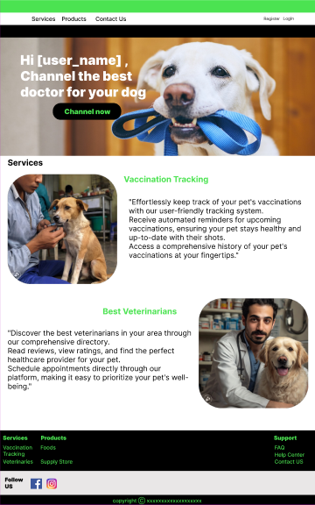 Home Page

Register

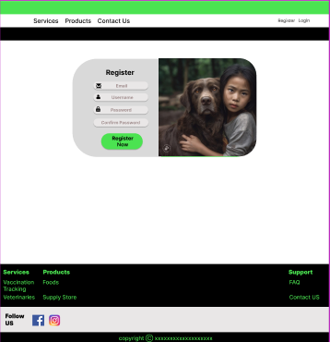

Login

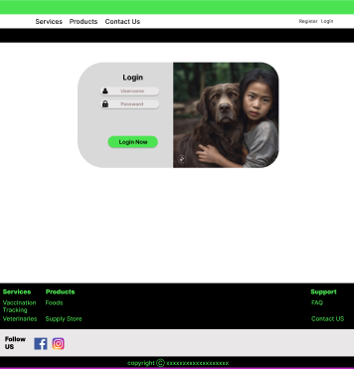

Pet Register

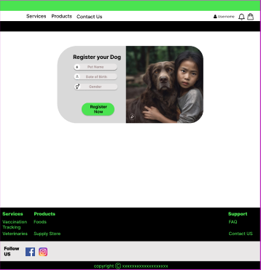

Services

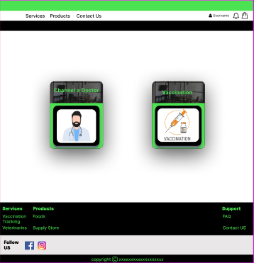

ContactUs

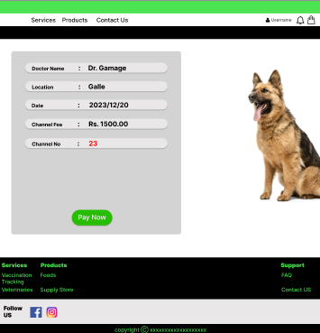

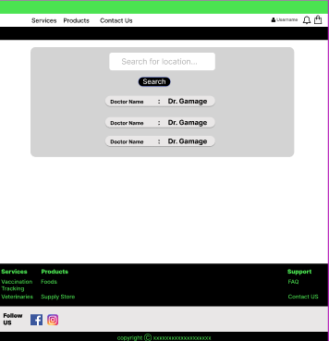

Doctor Channelling

Stores

Add to Cart & Buy Now

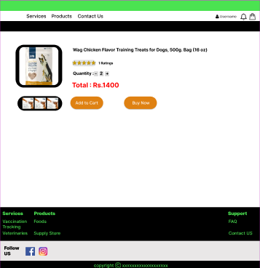

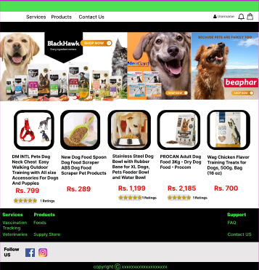

**07. Test Cases-->**

|  |  |  |  |  |  |
| --- | --- | --- | --- | --- | --- |
|  | **Test Case** | **Input** | **Expected Output** | **Actual Output** | **Status** |
| 01. | User Registration | Email, Username, Password | User successfully registered. | User registration successful. | Pass |
| 02. | User Login | Username, Password | User successfully logged in. | User login successful. | Pass |
| 03. | Create Dog Profile | Dog Name, Gender, Date of Birth | New dog profile created. | Dog profile added successfully. | Pass |
| 04. | View Dog Details | Select Dog or Enter Dog ID Number | User views detailed information | Dog details displayed | Pass |
| 05. | Schedule Veterinary Appointment | Date, Time, Reason | Appointment scheduled for (date) at (time) for (reason). | Veterinary appointment scheduled for (date) at (time). | Pass |
| 06. | Receive Vaccination Notifications | Dog ID, Upcoming Vaccination Date | User receives a notification upcoming Annual Check-up. | Notification received Annual Check-up due on (date). | Pass |
| 07. | Contact System Support | User sends a message regarding a system issue. | Administrator receives the message and responds appropriately. | User receives a response from the Administrator. | Pass |
| 08. | View Available Services | User navigates to the services section. | User sees a list of available services for their dogs | List of available services displayed | Pass |
| 09. | View Available Doctors | User checks for available veterinarians | User sees a list of veterinarians and their details | List of available veterinarians displayed. | Pass |
| 10. | View Doctor's Schedule | User selects a veterinarian and checks their schedule | User sees the available time slots for the selected veterinarian | Schedule for the selected veterinarian displayed. | Pass |
| 11. | Check Reserved Slots | User views the number of reserved slots for a specific doctor. | User sees the count of currently reserved slots. | Count of reserved slots displayed. | Pass |
| 12. | Channel a Doctor | User books a channel for a veterinarian. | User receives confirmation and details of the channel. | Channel booked successfully, and confirmation sent. | Pass |
| 13. | View Channel Receipt | User views the detailed receipt of a booked channel. | User sees a comprehensive receipt with channel details. | Detailed receipt displayed. | Pass |

|  |  |  |  |  |  |
| --- | --- | --- | --- | --- | --- |
| 14. | Check Channelling Process | User verifies the step-by-step channelling process. | User understands each step in the channelling process. | Clear steps for channelling process explained. | Pass |
| 15. | View Available Product Categories | User explores the store section. | User sees a categorized list of available products. | List of product categories displayed. | Pass |
| 16. | View Available Dog Products | User selects the "Dog Accessories" category. | User sees a list of available dog accessories. | List of dog accessories displayed. | Pass |
| 17. | Add Products to Cart | User adds a dog toy and a leash to the shopping cart. | Selected items added to the cart. | Dog toy and leash added to the | Pass |

**08. Resources-->**

Prototyping Model:

<https://www.figma.com/file/P5bZ8dQnwn7ZmYmZ4nYAg7/Untitled?type=design&node-id=0%3A1&mode=design&t=jt3MriV8H5yEzael-1>

Visited Site:

<https://www.rspca.org.uk/adviceandwelfare/pets>

<https://www.cogniteq.com/blog/iot-pet-tech-solutions-future-smart-technologies-pets>

Got help:

<https://chat.openai.com/c/7c9647e4-c2b3-4ab4-85f0-5429382e5f47>

<https://bard.google.com/chat/de3fa4c8e2514d7a>